**Equity within Gifted Programs**

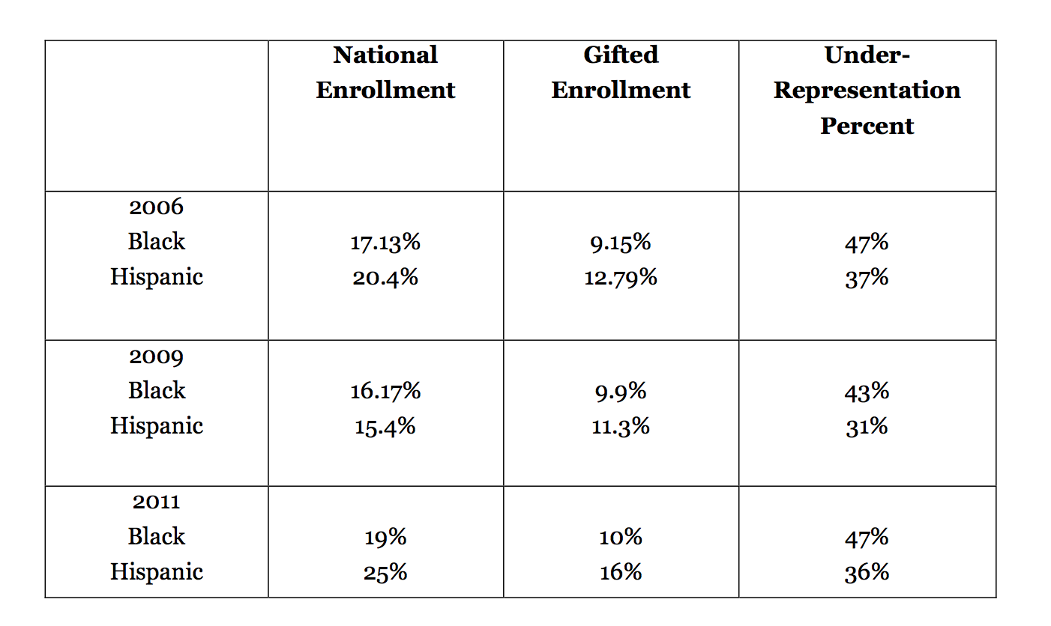One of the many glaring issues is that CLD students are greatly underrepresented in gifted programs nationwide and have been historically. Figure 1.1 contains gifted identification data from the 2006, 2009, and 2011 from the Office of Civil Rights. Additionally, Figure 1.1 contains the percentage of underrepresentation for Black and Hispanic students as calculated by the Relative Difference in Composition Index (RCDI), explained in the following paragraph.

*Figure 1. Black and Hispanic Students: Under-representation in Gifted Education Nationally (2006, 2009, 2011)*. From Wright, Ford, & Young (2017, p. 53).

It is clear from the national data that inequities in gifted education exist with regards to the underrepresentation of CLD groups. Despite evidence of inequitable practices, there are numerous ways that the term “equity” has been conceptualized and defined in the field of gifted education. One common way is to define equity is by using the Relative Difference in Composition Index (RDCI). The RDCI “for a racial or cultural group is the difference between their gifted education composition and general education composition, expressed as a percentage of their general education composition” (Ford, 2014, p. 144). For example, in the context of gifted education, if a group had an RCDI of -30 this means that was a 30% discrepancy between that group’s representation in schools and its representation in a gifted education program. While this number is helpful when comparing levels of underrepresentation across groups, it “not adequate for determining what is unacceptable or possibly illegal/discriminatory underrepresentation; nor is it specific enough to determine goals for improving representation” (Ford, 2014, p. 145).

A second helpful way to conceptualize equity in gifted education is by using The Office of Civil Rights 20% Equity Threshold, commonly referred to as the Equity Index (EI) in gifted research and state documents (e.g., Ford, 2014; Texas Education Agency, 2009; VDOE, 2017a Wright, Ford, Young, 2017). The EI should theoretically be the minimally accepted level of underrepresentation for each group because once the percentage of underrepresentation exceeds that designated threshold, it is beyond statistical chance, meaning policies and procedures may be discriminatory against CLD groups (Ford, 2014). To illustrate this point consider the fact that 10% percent of African American/Black students identified as gifted in the U.S. in 2011, yet they comprised 19% of total enrollment in public schools. After calculating the EI for this group (formulas for calculating RCDI and EI are in Appendix C), the targeted goal for the minimum percentage of African American/Black students identified as gifted in 2011 would have been 15.2%. However, as noted above, this minimum threshold was not met, therefore leading us to the conclusion that underrepresentation is significant beyond statistical chance and the identification of this group is inequitable.

**Calculations and Interpretations of RCDI and EI**

*RDCI Calculation and Interpretation*

Donna Ford (2014) provides the following formula for calculating RCDI for underrepresentation:

{[( Composition (%) of African American in gifted education) − (Composition (%) of American students in general education)] / (Composition (%) of African American students in general education)}∗ 100.

To illustrate this, we will use data from the Office of Civil Rights from 2011. During that year our nation comprised of 19 percent of African American/Black students. The percentage of those students identified as gifted was 10 percent. To calculate the RCDI you would do the following:

{[(10) − (19)] / (19)}∗ 100= -47.4

This means that there was a 47.4% discrepancy between representation in schools and representation in gifted education programs for African American/Black students in 2011.

EI Calculation and Interpretation

Donna Ford (2014) provides the following formula for calculating EI.

EI is calculated in two steps:

1. (Composition (%) of African American students in general education) × Threshold of 20% = A. This is abbreviated as C ×T = A.
2. (Composition (%) of African American students in general education) − A = EI. This is abbreviated as C − A = EI.

From our prior example the EI for African American/Black students in 2011 would be calculated as:

1. (19) × Threshold of 20% = A, or 3.8

1. (19) – 3.8 = 15.2

This means that the targeted goal for the minimum percentage of African American/Black students identified as gifted in 2011 would have been 15.2%. However, in 2011 the percentage of African American/Black students identified was 10%, therefore leading us to the conclusion that “underrepresentation is significant beyond statistical chance” (p. 146).